Good day,

First you will need to create the test database. In SQL Server Management Studio, create a backup of your live database then restore the backup as a new database specifying a new name in the Destination section of the Restore Database form as shown below:

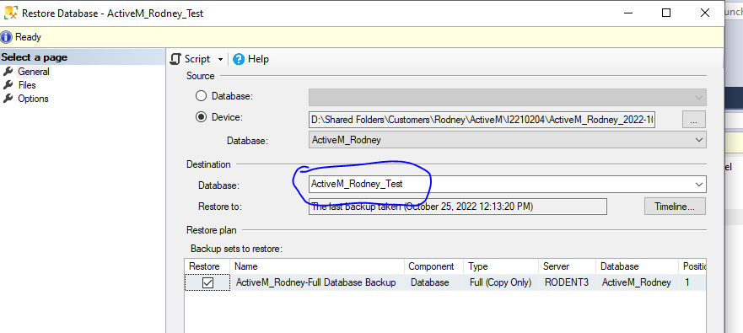
Since I like to keep database files isolated within their own folder, I recommend that a folder be created on the SQL Server for the test database files. This folder can then be selected on the Files page of the Retore Database form.
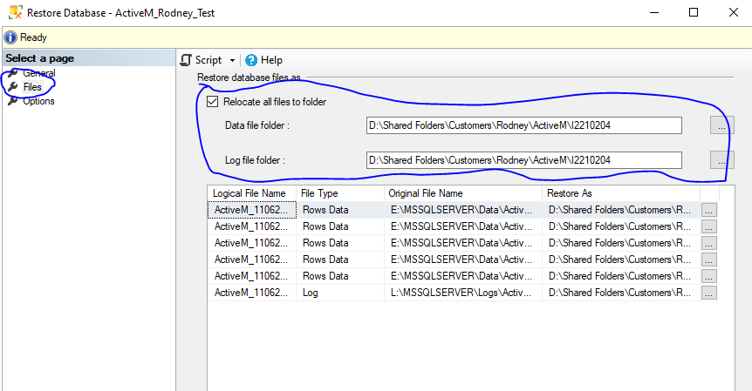
You need to grant access to the new database in SQL Server. Expand Security, expand Logins then right click on an applicable login and select Properties.
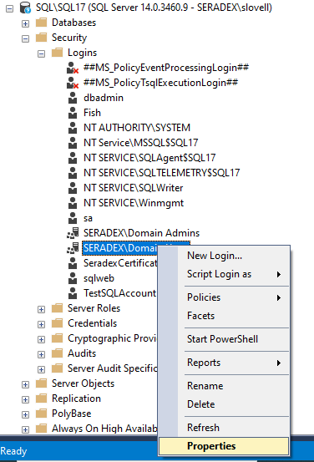
Click on the User Mapping page, select the test database then select db_owner.
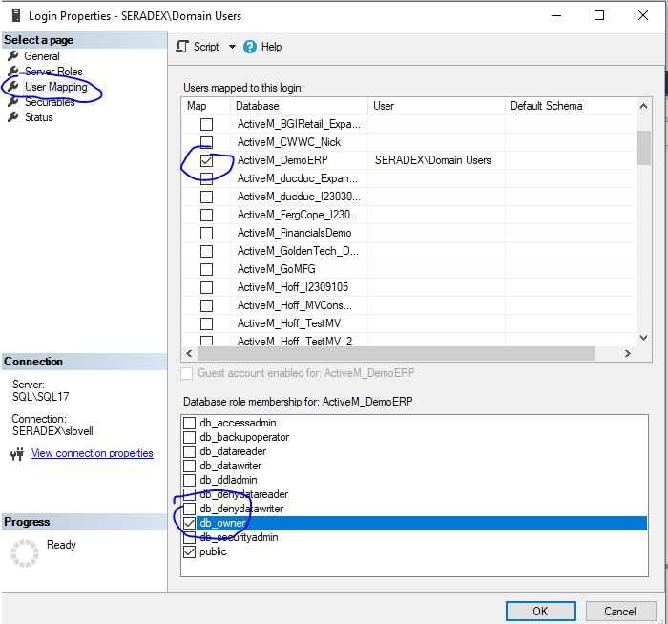
Once the test database has been created, open OrderStream then go to Admin Tools > Edit Profiles > Tools > Database Setup. Click Add and fill out fields as follows:
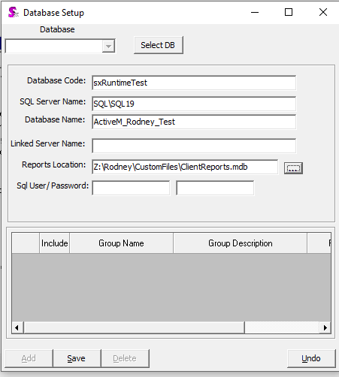
The database code is used as the identifier of the database and will be assigned to the OrderStream shortcut you create to run OrderStream connected to the test database. More on that later.
The SQL Server name is the name of your SQL server and the SQL Server instance name (if an named instance of SQL Server was installed).
The Database Name is the name you assigned to the test database when you created it.
The reports location is the path and file name of your reports MS Access database.
Click Save.
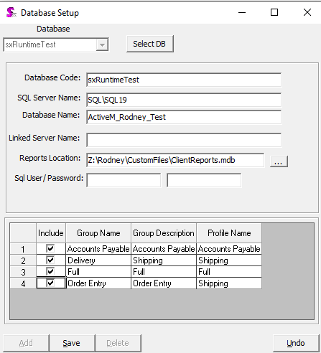
After saving your existing security groups will load in the bottom grid. Check Include for the groups you wish to have access to the test database then Save.
Finally, as mentioned above you need to create a shortcut. Copy the existing shortcut that’s on your desktop and give it an appropriate name (i.e. OrderStream Test). Right click on the new shortcut then select Properties. In the Target text box, after the path and executable name, enter the Database Code you entered when setting up the database via the OrderStream database setup form:
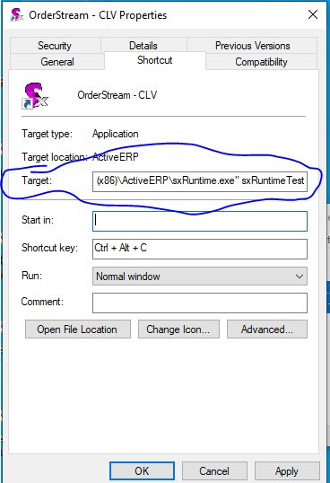
Click okay and use the new shortcut to run OrderStream. Go to Utilities > Company Setup then click on the Additional Information tab. Enter a name that will identify this database as the testing database into the Secondary Company Name text box then save.
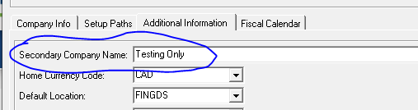
You should now be ready to test!

